Temperature and Precipitation data correction methods: data gap filling at
Mukhem IMD station
Group 7, Raghav Ramani, Rangesh Soni, Prince Jaiswal, Raman Meena (180004019-180004022)

1. Introduction
Precipitation is very commonly used for the analysis of the climatic variability. The forecasting models incorporates high correlations with the values of precipitation. There are instances when sudden extreme climatic conditions may disable us to gather the values of such important hydro-logical parameters. Though, techniques like remote sensing may be helpful in such cases, but due to systematic and other malfunctioning there are missing data, incorrect data, or other issues in the data.
This leads us to correct our data using certain statistical methods. Also, there missing data in regions have become a major issue in analyzing the hydro-logical parameter. In this documentation, four separate methods to fill the missing data with appropriate values. Our study is over a village in Uttrakhand namely Mukhem, India.

K-nearest neighbor imputation method incorporates the fundamentals of finding the missing precipitation values using the neighbor gauge data. Empirical Orthogonal Functions (EOF) reconstruction is recommended for the continuous evenly spread data, unlike the case of precipitation which can be discontinuous and uneven. This method can give better values for data gaps of temperature and pressure because of their continuous nature. This method gives acceptable values for the data gaps in between the matrix due to gradually increase of generated matrix, the values obtained for the data gaps towards the end after matrix. Moving on to the forecasting models, ARIMA (Hillmer and Tiao) is considered as a suitable model which incorporates the moving averages as well as auto-regression with differencing features. But there are disadvantages of ARIMA model (Usually, Time Series), since these are the traditional model identification techniques they are unable to forget the values which are irrelevant to be taken in study. Also, they don’t have any memory unit for remembering the previous values for long time duration. For such cases machine learning and deep learning models play a major role in solving such issues for time series data. For this recurrent neural networks are best solutions and are in high demand with great solution efficiencies in today’s growing world. A Recurrent Neural Network (RNN) is a class of artificial neural networks where connections are between nodes form a directed graph along a temporal sequence (Rumelhart et al.). Vanishing gradient is a drawback of this model. For this reason, RNN models are not suitable for time series data implementation. The above problems can be solved by Long short-term memory architecture. Long short-term memory (LSTM) was proposed in 1997 by Sepp Hochreiter and Jürgen Schmidhuber (Hochreiter and Schmidhuber). By introducing Constant Error Carousel (CEC) units (Gers et al.), LSTM deals with the vanishing gradient problem. The LSTM includes cells, input and output gates. In 1999, Felix Gers and his advisor Jürgen Schmidhuber and Fred Cummins introduced the forget gate (also called “keep gate”) into LSTM architecture, enabling the LSTM to reset its own state (Greff et al.). In 2000, Felix Gers, Jürgen Schmidhuber & Fred Cummins added peephole connections (connections from the cell to the gates) into the architecture. Additionally, the output activation function was omitted. In 2014, Kyunghyun (Cho et al.) put forward a simplified variant called Gated recurrent unit (GRU). Briefly, LSTM is an artificial recurrent neural network (RNN) architecture used in the field of deep learning. Unlike standard feed forward neural networks, LSTMs has feedback connections. It can process single data points, as well as entire sequences of data. LSTM architecture was created as the solution to short-term memory.

2. Abstract
The correction and missing data problem are solved by the few methods on the Mukhem village data. We implemented four separate models in this project and compared there efficiencies. They include K-nearest neighbor imputation, Empirical Orthogonal Functions, Auto-regressive integrated moving average (ARIMA), and a deep learning model namely Long-short term memory (LSTM). All the models are trained on the training data and then tested on the testing as well as artificially generated missing data.

3. Data-set and Study area
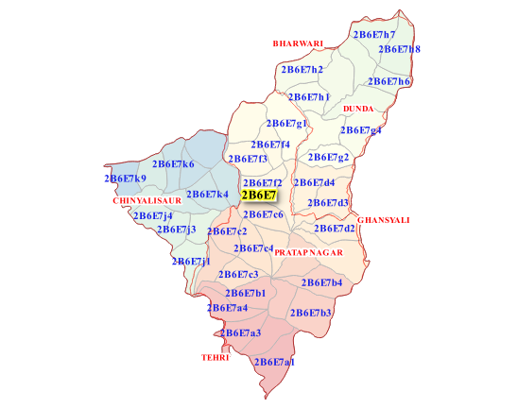fig 1: Watershed
In our study we have gathered monthly time series data from an online source (MERRA - Www.Soda-pro.Com) for Mukhem village, Pratapnagar, Uttrakhand, India. The data-set comprises of monthly data for temperature and precipitation from 1990-2020. Since, the data is satellite data, thus there are no missing data present explicitly, but for our study we will be creating synthetic missing data using random function and predict its value using are models, thereafter comparing it with the observed value for checking the efficiency of our model.
4. Methodology
We need find the missing precipitation data, for this we are going to create ‘Artificial data gaps’ and predict the precipitation value using four models. All four models are compared with each other using the statistical indices like R2 score, RMSE, and Kling-Gupta efficiency. From (Knoben et al.) Kling-Gupta efficiency is advantageous over NSE value, thus for analysis the goodness of a model such statistical parameter will be used. These statistical parameters are evaluated on the test data and missing data (MD) individually for more specific analysis at specific time steps.
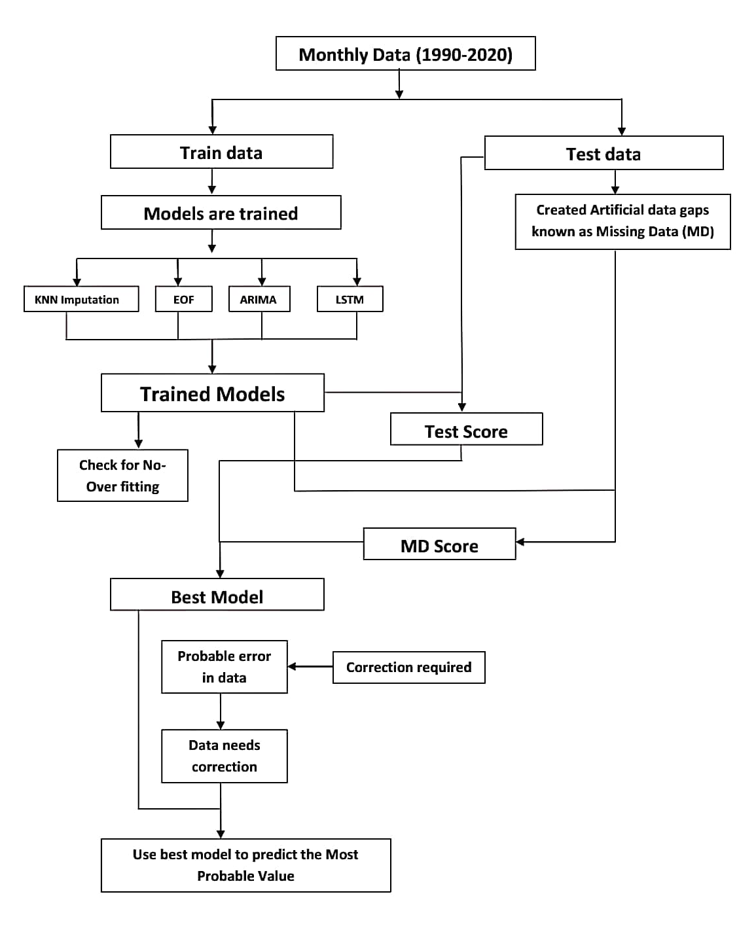
Below is the flowchart representing the sequence of procedures to followed to obtain our results.

4.1. K-nearest neighbors imputation
The method requires the time series data for all nearer weather stations. In our case, we obtained the time series data for all the near gauges present in the same watershed. They are namely, Deen Gaon, Saundi, Pratap nagar, Tehri range, Pokhari, and Rampur. These all lie in the same watershed (fig 1) naming 2B6E7 (2B6E7 @ Slusi.Dacnet.Nic.In , n.d.).
This model finds the station with highest correlation from the considered station list. In our case study, we obtained the nearest station has the highest correlation between its values and that of reference station (Mukhem station) which allowed us to take similar values. This model is also known as Hot-deck model.

Thus (1)

4.2. Empirical Orthogonal Functions
The EOF reconstruction uses the empirical orthogonal functions for modification of data gaps which are filled with most appropriate assume values / mean. This method was given by Beckers and Rixen in 2003 (Beckers and Rixen). For filling the data gap, firstly a small set from a big chunk of data is taken and gaps are filled simply with mean values. Particularly for precipitation, the data gaps are filled by average rainfall for that particular year. Data matrix is single value decomposed into 3 matrices and multiple iterations are performed with a path of these decompose mattresses to recreate data matrix. This newly formed matrix have values for data gapps which are usually better than the average values. All data values excluding newly generated data gap values are copied from original data. The ratio of variance/noise provides determination condition for iterations. Finally, the matrix obtained have data capture field. The computation for deviation from the mean value can be found for each gap.

4.3. Auto-regressive integrated moving average
This is used majorly in time series analysis, and our used for predicting values. In our case, we used “statsmodels” library for the implementation of ARIMA architecture. Below are the mathematical equations involved in the Auto regressive (AR) and Moving averages (MA).
For AR, (2)
Here in (2) depends on its own lag.
For MA, (3)
Here in (3) depends only on lagged forecast errors, where error terms are .
ARIMA is the combination of above two equations, thus in literature ARIMA can be written as summation of constant, linear combination lag of (up-to p lags) and linear combination of lagged forecast errors (up-to q lags). In order to make the time series stationary we use ‘differencing’ . In our study, we found the values p, q, and d using hit and trial and optimizing the hyper parameter values we obtained , and . Each value was first predicted and thereafter used for predicting next values. The uni-variate precipitation data was used in the value with no missing values, and thereafter the model was tested on artificial missing data. Finally, the efficiency of model was analyzed using the statistical parameters.
A chunk of code is shown in the fig 2.
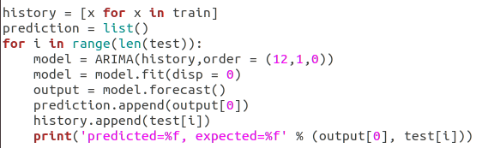fig 2: ARIMA code
4.4. Long-short term memory
This is a deep learning model with high time series learning rates. This is a special kind of recurrent neural network with added features. They are explicitly designed to avoid the long-term dependency problem (Colah.Github.Io). They can learn information for long period of time which is their default behavior. Fig 3 shows the repeating module in an LSTM contains four interaction layers.
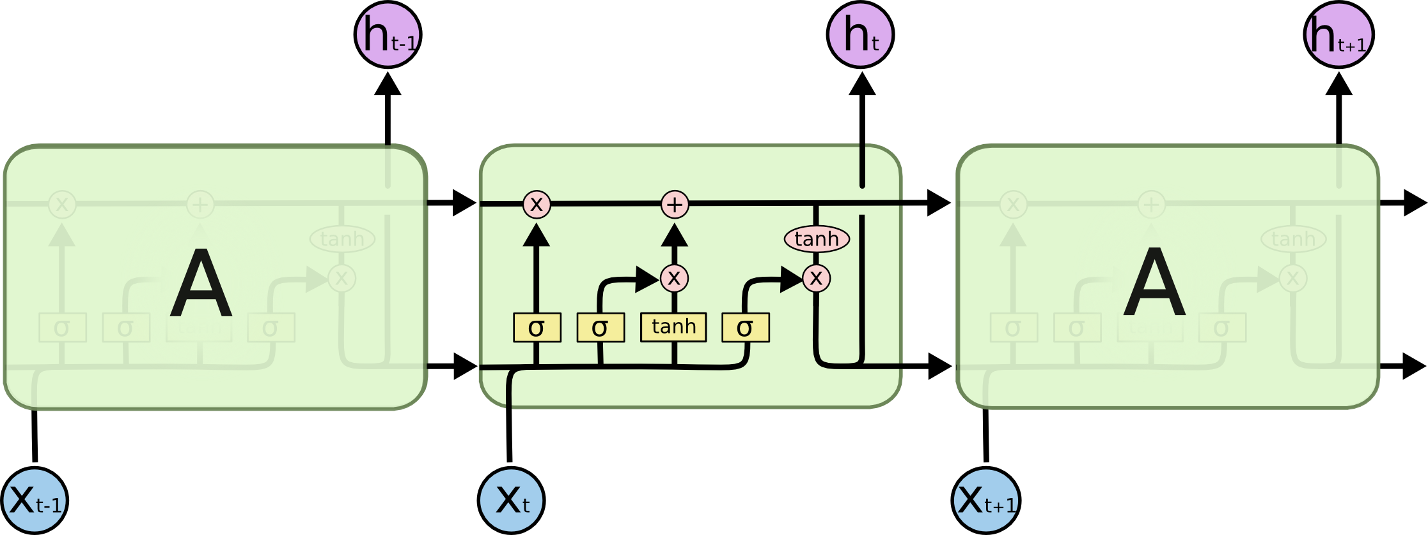fig 3: Repeating module in an LSTM
In our case we implemented the model over the uni-variate data-set of precipitation. The model was implemented using Keras library in python. Our model comprises of 4 layer neural network model including one Sequential as the ground layer, 3 LSTM layers and lastly a Dense layer. For compiling our model we used mean squared error (MSE) as the loss function and Adam optimizer. Other hyper parameters includes a batch size of 4 and a verbosity of 2. Finally the model was trained on 150 epochs. The data considered is assumed to be 100% clean with no missing data. Once the model was created the artificial missing data was predicted and efficiency of the results were calculated using the statistical parameters. Fig 4 shows the chunk of LSTM code in python.
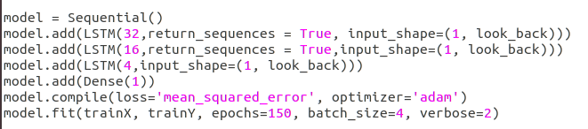fig 4: LSTM code
4.5. Correction model implementation
In our study, we have finally obtained the best model out of the above four models. In case of correcting a value assuming the reference station gauge value is incorrect, one can use above models to predict the probable value at that particular time instance . Thereafter error is evaluated with respect to the observed value from reference station gauge. In case the error value belongs to the range of , then the observed value from the reference station has to be corrected or replaced. This observed value may be termed as an outlier or an anomaly in the data-set, and can be due to extreme Eco-climatic indices. In case of no extreme climate observed at that particular time instance, we can conclude the observed value must be replaced by the predicted value by our best suitable model, considering that our predicted results are correct.

5. Results and discussion
The models were compared with each other using the statistical parameters namely root mean square error, R2 score, and the kling-Gupta efficiency. In the Table 1, test data indicates the duration when the model is tested, whereas MD indicates the data where artificially data is removed and values are predicted to analyze the correctness of predicted values.

 | Statistical parameters
 | 0.00 |  | 0.00 |  | 0.00
Models | Test Data | MD | Test Data | MD | Test Data | MD
KNN | 0.012 | 0.010 | 0.998 | 0.999 | 0.980 | 0.980
EOF | 0.150 | 0.050 | 0.801 | 0.950 | 0.816 | 0.821
ARIMA | 0.157 | 0.151 | 0.749 | 0.871 | 0.807 | 0.905
LSTM | 0.086 | 0.094 | 0.825 | 0.908 | 0.830 | 0.935
Table 1: Statistical scores of each models for test and missing data
From Table 1, we can observe that the KNN model shows its best results with high values of statistical parameters. But this observation is possible only on the assumption that the data of the nearest station is available completely. Thus, this cannot be considered as the best model for predicting values, since there are probabilities that the data missing in one region may have caused due to some extreme Eco-climatic conditions, and thus have affected the nearer stations too. Hence, this model is suitable only when we are sure about the readings taken by the nearest station.
We can conclude from the table that EOF model is giving good predictions, but the kling-Gupta efficiency is quite smaller for it. Therefore, on the basis of Kling-Gupta efficiency we can conclude that ARIMA and LSTM models works very well in predicting missing values.
Fig 5 and Fig 6 shows the fitting of the predicted data on the observed values for the missing point indices in data-set considered for ARIMA and LSTM models respectively. From both the figures and table 1 we can observe that LSTM model has superior results than ARIMA model for missing data. In LSTM model the predicted values are able reach the maximum values with minimum loss, whereas ARIMA model does not.
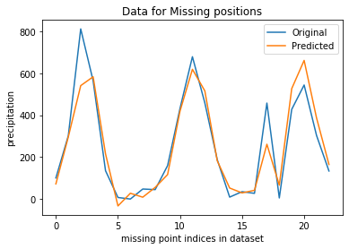fig 5: ARIMA model
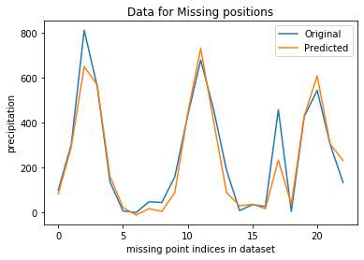fig 6: LSTM model

6. Conclusion
Hence we can conclude that out of all the four models implemented LSTM has superior results in all cases except when KNN model is applicable, i.e. when assumptions considered are true in real world situations. LSTM is a new and evolving technology with high learning rates and overcoming gradient descend problems. For correction model, this was our new approach in correcting the observed values at the reference stations. This approach has still be tested on other datasets for its universal usability.
Thus, we can use long-short term memory model for finding the missing values for a time-series precipitation and temperature data and even correcting data. The whole case study with sources codes, libraries, implementations are available on the GitHub repository (here).

7. References

- 2B6E7 @ Slusi.Dacnet.Nic.In. http://slusi.dacnet.nic.in/dmwai/Uttarakhand/District/watershed/2B6E7.html.
- Beckers, J. M., and M. Rixen. “EOF Calculations and Data Filling from Incomplete Oceanographic Datasets*.” Journal of Atmospheric and Oceanic Technology, vol. 20, no. 12, Dec. 2003, pp. 1839–56, doi:10.1175/1520-0426(2003)020<1839:ECADFF>2.0.CO;2.
- Cho, Kyunghyun, et al. “Learning Phrase Representations Using RNN Encoder-Decoder for Statistical Machine Translation.” EMNLP 2014 - 2014 Conference on Empirical Methods in Natural Language Processing, Proceedings of the Conference, 2014, pp. 1724–34, doi:10.3115/v1/d14-1179.
- Colah.Github.Io. http://colah.github.io/posts/2015-08-Understanding-LSTMs/.
- Gers, Felix A., et al. Learning to Forget: Continual Prediction with LSTM. IET, 1999.
- Greff, Klaus, et al. “LSTM: A Search Space Odyssey.” ArXiv E-Prints, Mar. 2015, p. arXiv:1503.04069.
- Hillmer, Steven Craig, and George C. Tiao. “An ARIMA-Model-Based Approach to Seasonal Adjustment.” Journal of the American Statistical Association, vol. 77, no. 377, Taylor & Francis, 1982, pp. 63–70.
- Hochreiter, S., and J. Schmidhuber. “Long Short-Term Memory.” Neural Computation, vol. 9, no. 8, Nov. 1997, pp. 1735–80, doi:10.1162/neco.1997.9.8.1735.
- Knoben, Wouter J. M., et al. “Technical Note: Inherent Benchmark or Not? Comparing Nash-Sutcliffe and Kling-Gupta Efficiency Scores.” Hydrology and Earth System Sciences Discussions, no. July, 2019, pp. 1–7, doi:10.5194/hess-2019-327.
- MERRA - Www.Soda-pro.Com. http://www.soda-pro.com/web-services/meteo-data/merra.
- Rumelhart, David E., et al. “Learning Representations by Back-Propagating Errors.” \nat, vol. 323, no. 6088, Oct. 1986, pp. 533–36, doi:10.1038/323533a0.
- Usually, Time Series. 1996, pp. 1–64.

